AWS Guide Performing Dynamic Data Frame with Athena Query

# Introduction

This guide walks you through the detailed steps to perform a dynamic data frame operation using AWS Glue and Athena. Follow the instructions carefully to execute the query and view the results successfully.

# Let’s get Started

## Steps to Get Started

### Step 1: Access Glue Studio

* Open your web browser and navigate to [AWS Glue Studio](https://us-west-2.console.aws.amazon.com/gluestudio/home?region=us-west-2#/editor/job/Aws%20Glue%20-%20Dynamic%20Frame%20-%20Pyspark/notebook).
* Sign in with your AWS credentials if prompted.

### Step 2: Open Job Editor

* Click on the link provided to access the job editor in Glue Studio.

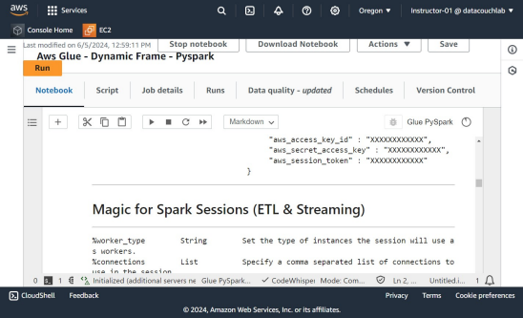

* Ensure you are in the correct AWS region (us-west-2).

### Step 3: Switch to S3 Bucket Tab

* Locate the tab named "awstrainingjune01 - S3 bucket | S3 | us-west-2".

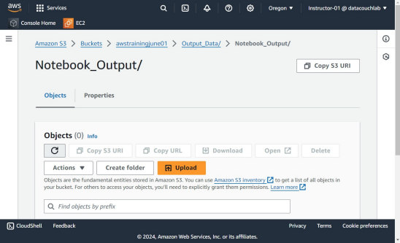

* Click on this tab to switch to the S3 bucket view.

### Step 4: Reload the Page

* Click the "Reload" button located on the top right of the page.

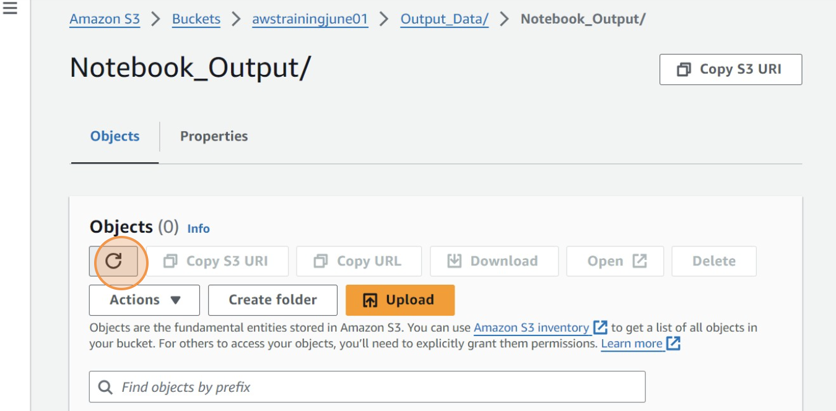

* Wait for the page to refresh and display the latest content.

### Step 5: Navigate to the S3 Bucket

* Follow this path to locate the S3 bucket:

Services > Oregon > Instructor-01 @ datacouchlab > Console Home > EC2 > Amazon S3 > Buckets > awstrainingjune01 > Output_Data/ > Notebook_Output/

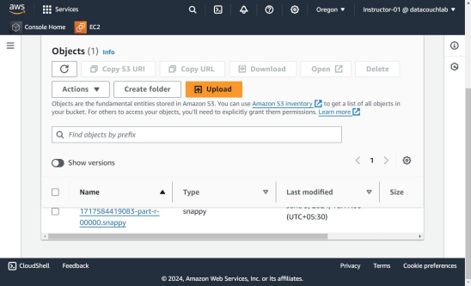

* Click on the "awstrainingjune01" bucket to open it.

### Step 6: Select the Snappy File

1. Within the "Output_Data/Notebook_Out" directory, look for the Snappy file.

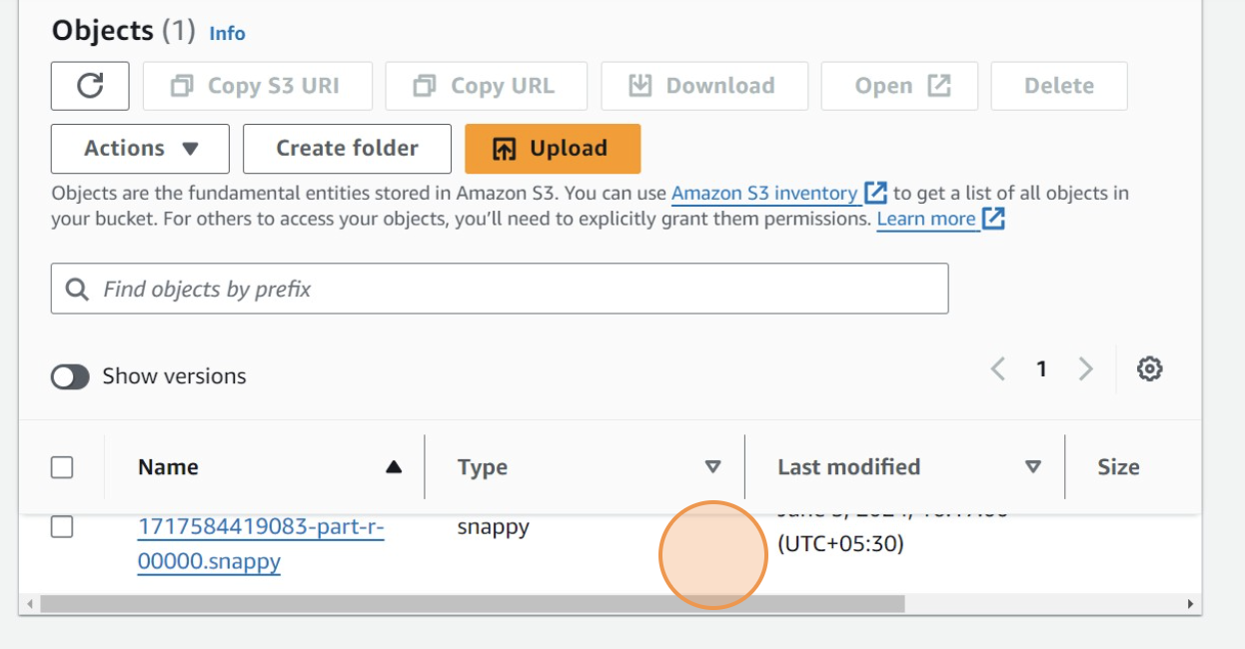

1. Click on the Snappy file to select it.

### Step 7: Switch to Athena Query Editor

1. Locate and click on the tab labeled "Query editor | Athena | us-west-2".
2. Ensure you are in the correct AWS region (us-west-2).

### Step 8: Open Query Editor

1. Click the button to open the query editor within Athena.

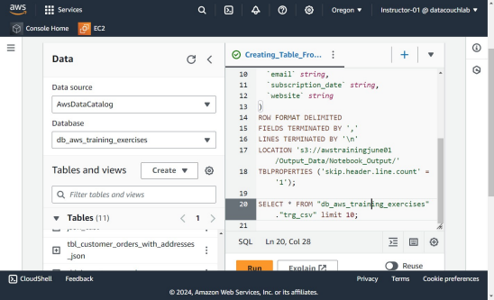

1. Wait for the editor to load fully.

### Step 9: Execute the Query

1. Press Ctrl + A to select all the text within the query editor.

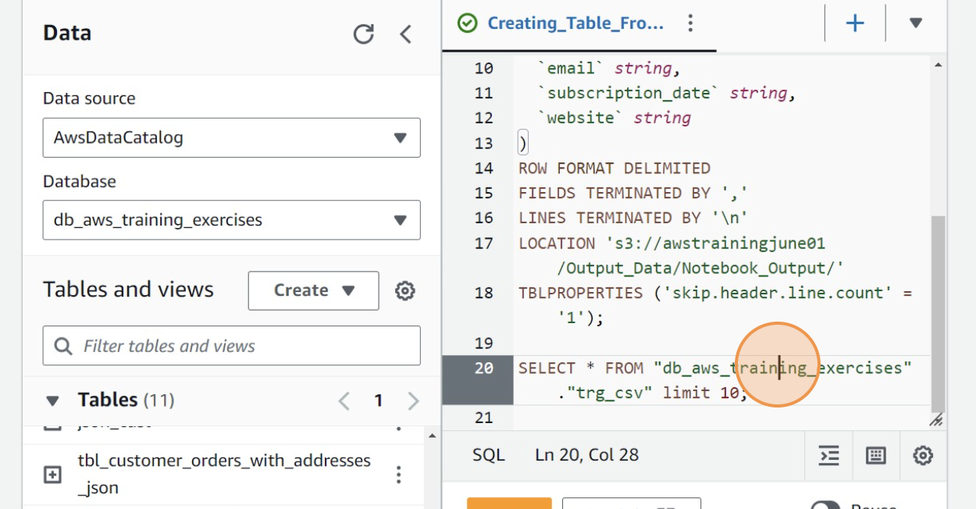

1. Click the "Run" button to execute the query.

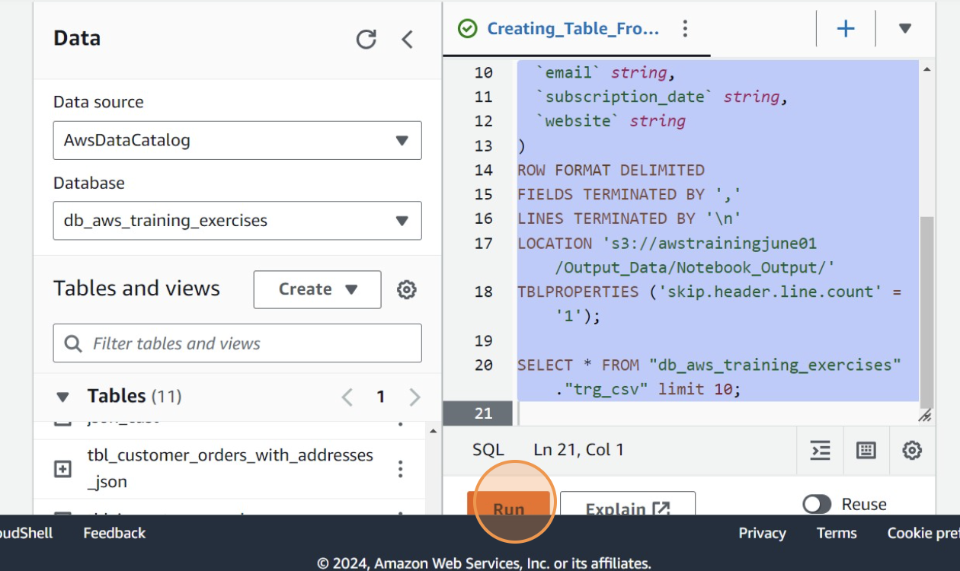

1. Wait for the query to complete and display results.

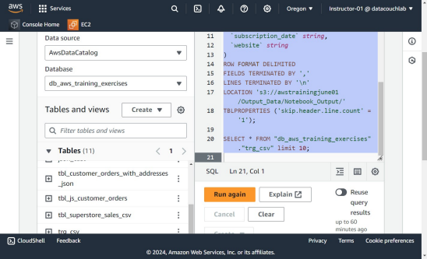

### Step 10: Delete Previous Queries

1. Click the button to open the delete dialog.
2. Press Ctrl + X to cut all the text from the editor.
3. Confirm the deletion by clicking the delete button.
4. Type "delete" in the confirmation dialog that appears.
5. Press Ctrl + A to select all the text again.
6. Click "Run" to execute the deletion command.

### Step 11: Paste New Query

1. Click the button to open the editor again.
2. Press Ctrl + V to paste the new query into the editor.
3. Click "Run" to execute the new query.
4. Wait for the query to complete and verify the output.

### Step 12: Preview the Results

1. Click on the "Preview Table" button located on the top right of the editor.

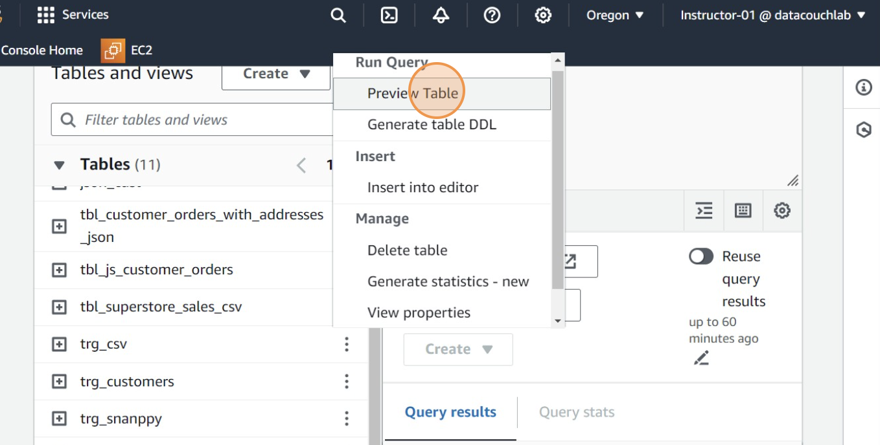

1. Review the table to ensure the results are as expected.

## Conclusion

Following these detailed steps will enable you to perform a dynamic data frame operation using AWS Glue and Athena effectively. If you encounter any issues, refer to AWS documentation or contact AWS support for further assistance..